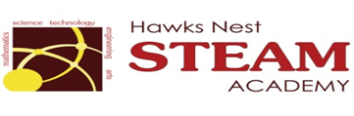School Counseling Program Newsletter
Shandrai Silva, School Counselor | February 2018

Counselor Message  Happy February! The school counseling program is looking forward to a great second half of the school year.  In January, the school counseling program continued with classroom guidance lessons, small group counseling and individual meetings with students. We recognized No Name- Calling Week which included Student Council sharing a skit and facilitating discussions with some of the lower grade students. Students also had an opportunity to participate in the Great Kindness Challenge Week by completing a kindness challenge and participating in kindness lessons.  See what’s happening in February.  It’s going to be another great month at  the Nest!  _________________________  How to see the school counselor  Classroom guidance classes are weekly based on grade level specials schedule. Small group counseling and individual counseling by self -referral, parent referral, teacher referral, administrator referral or counselor initiated.  Contact School Counselor at 704-866-8467or sosilva@gaston.k12.nc.us.  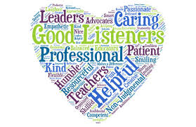 | Home of the Hawks    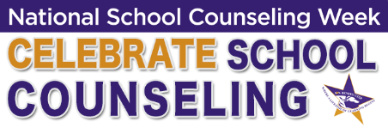  February 5 - 9, 2018  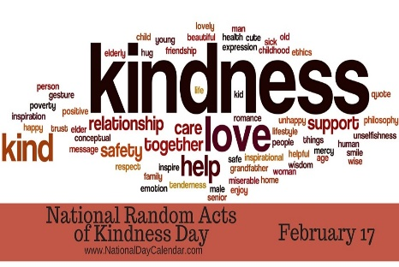  NATIONAL RANDOM ACTS OF  KINDNESS DAY – February 17    Black History Month  February 2018 | Character Education  “We’re Soaring with Good Character”  ______________________________  The character trait of the month is Self-discipline. Self-discipline means being responsible for your actions; being in charge of the things you say and do and making choices that are healthy, safe, kind and respectful to others.  __________________________________  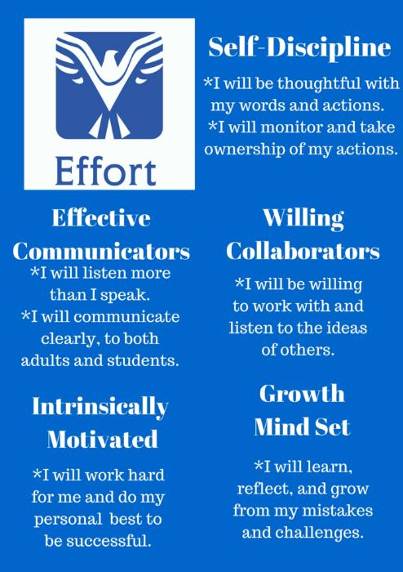  http://www.edgebrookschool.org/apps/pages/index.jsp?uREC_ID=205243&type=d&pREC_ID=405995  “Intelligence plus character- that is  the goal of true education.”  Dr. Martin L. King, Jr.  

